The Global ABC, Inc. Case Background Information Global ABC, Inc. (the Company) designs, engineers, manufactures, markets and sells a broad range of advanced engines and power systems that are powered by a wide variety of fuels, including natural gas, propane, gasoline, diesel and biofuels, within the energy, industrial and transportation end markets with primary manufacturing, assembly, engineering, research and development, sales and distribution facilities located in suburban Chicago, Illinois, and Darien, Wisconsin. The Company manages the business as a single segment. The Company’s products are primarily used by global original equipment manufacturers (OEMs) and end-user customers across a wide range of applications and equipment that includes, but not limited to, standby and prime power generation, agricultural and turf, construction, compressors, utility vehicles, vocational trucks, and school and transit buses. Through advanced research and development and engineering capabilities, the Company is able to provide its customers with highly optimized, efficient, durable and emissions-compliant products that enhance their competitive position. The Company sells a lot of the engines to customers who manufacture large generators that used to create power. These generators are often used in remote areas off the traditional energy grid (most often oil and gas fields) as well as to provide backup power to buildings. The Company’s business is diversified across end markets and applications and also includes extensive aftermarket and service parts programs. These programs consist of (i) internal aftermarket service parts programs with worldwide sales and distribution capabilities and (ii) internal OEM-developed service parts programs for components and products supplied by the Company. The Company has not paid any cash dividends on its Common Stock to date. The payment of dividends has been restricted by the Credit Agreement and the indenture governing the Unsecured Notes. The Company intends to retain its future earnings to support operations and to finance expansion. Lastly, since mid-2016, the Company incurred substantial costs related to its restatement of prior financial statements and efforts toward remediation of its material weaknesses. The Company successfully reduced these costs with the completion of the restatement of its prior financial statements in May 2019. The Company is now current with their financial statement filings and as it continues to work on remediation of its material weaknesses. There is a stronger demand for increased sales within the energy end market were primarily attributable to stronger demand for power generation products, including those used within the oil and gas market, and increased demand for demand response products, higher demand for products used in the medium-duty truck market in recent two years. One of the Company’s customers, Local Coco, requested to receive a shipment of certain engines, with a value of $30,000, during the fourth quarter of 2019 that were originally scheduled for the first half of 4 | P a g e 2020. During 2019, the Company experienced a loss by marking its warrant liabilities to their fair market value in recent years, which were exercised in April 2019. The Company offers a standard limited warranty on the workmanship of its products that in most cases covers defects for a defined period. The Company estimates and records a liability and related charges to income for its warranty program at the time products are sold to customers. Future warranty costs are initially estimated, based on historical experience, when products are sold and are re-evaluated each period based on recent activity. The company experienced warranty costs of $10,100 in 2019 and $18,600 in 2018. Most of the Company’s contracts are for a period of less than one year; however, certain longterm manufacturing and extended warranty contracts extend beyond one year. The timing of revenue recognition may differ from the time of invoicing to customers and these timing differences result in contract assets or contract liabilities. Contract assets include amounts related to the contractual right to consideration for completed performance when the right to consideration is conditional. The Company records contract liabilities when cash payments are received or due in advance of performance. The Company estimated the amount of contract assets and contract liabilities at the contract level in the following table (in thousands).

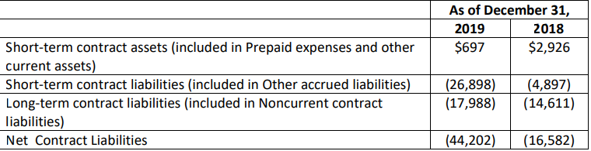

During the year ended December 31, 2019, the Company recognized $6.7 million of revenue upon satisfaction of performance obligations related to amounts that were included in the net contract liabilities balance as of December 31, 2018. The increase in the contract liabilities from December 31, 2018 to December 31, 2019 is primarily related to advance payments made by a customer under the terms of a long-term supply agreement executed between the parties. To be entitled to the advance payment, the Company had to secure inventory components that will be used to manufacture engines to fulfill orders committed to by the customer. . The Company has elected the practical expedient to not disclose remaining performance obligations that have expected original durations of one year or less. For performance obligations that extend beyond one year, the Company had $41.8 million of remaining performance obligations as of December 31, 2019 primarily related to long-term supply agreement discussed above and the sale of extended warranties. The Company expects to recognize revenue related to these remaining performance obligations of approximately $23.8 As of December 31, 2019 2018 Short-term contract assets (included in Prepaid expenses and other current assets) $697 $2,926 Short-term contract liabilities (included in Other accrued liabilities) (26,898) (4,897) Long-term contract liabilities (included in Noncurrent contract liabilities) (17,988) (14,611) Net Contract Liabilities (44,202) (16,582) 5 | P a g e million in 2020, $15.6 million in 2021, $0.7 million in 2022, $0.7 million in 2023 and $1.0 million in 2024 and beyond. The Company prepared a payment schedule of remaining maturities of long-term debt and lease payments as of December 31, 2019.

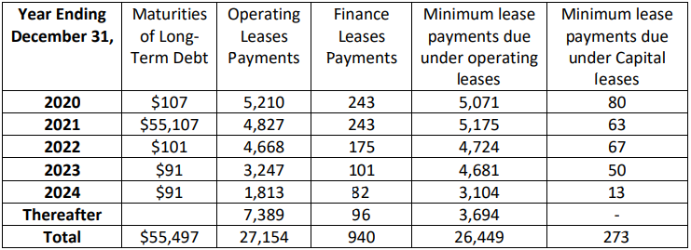

On March 27, 2020, the Company entered into a refinancing agreement with OneBank. The Agreement allows the Company to borrow up to $130 million, matures on March 26, 2021, with an optional 60-day extension subject to certain conditions and payment of a 0.25% extension fee. The Agreement is secured by substantially all of the Company’s assets and includes certain financial covenants as well as a change of control provision. On April 2, 2020, the Company borrowed $95.0 million under the Agreement and utilized the funds to (i) fully repay the outstanding balance of debt outstanding and related interest as of as of December 31, 2019, and (ii) for general corporate purposes. During the second quarter of 2020, the Company also drew the remaining $35.0 million available under their Agreement to provide for greater financial flexibility throughout the uncertain economic times. Excess cash was held in the Company’s bank account. In January 2020, the World Health Organization (“WHO”) announced a global health emergency because of the COVID-19 outbreak and the risks to the international community as the virus spreads globally. In March 2020, the WHO classified the COVID-19 outbreak as a global pandemic (the “COVID-19 pandemic”), based on the rapid increase in exposure globally. As of the date of the 2019 Annual Report, due to unprecedented decreases in demand, an oil price war, and economic uncertainty resulting from the COVID-19 pandemic, crude oil prices have declined precipitously. A significant portion of the Company’s sales and profitability is derived from the sale of products impacted by oil prices. While the Company has yet to experience significant supply chain interruptions or material cancellations of orders, the potential impact of future disruptions, continued economic uncertainty, and continued depressed crude oil prices, and declining rig count levels may have a significant adverse impact that may result in the recognition of material impairments or other related charges. These Year Ending December 31, Maturities of LongTerm Debt Operating Leases Payments Finance Leases Payments Minimum lease payments due under operating leases Minimum lease payments due under Capital leases 2020 $107 5,210 243 5,071 80 2021 $55,107 4,827 243 5,175 63 2022 $101 4,668 175 4,724 67 2023 $91 3,247 101 4,681 50 2024 $91 1,813 82 3,104 13 Thereafter 7,389 96 3,694 - Total $55,497 27,154 940 26,449 273 6 | P a g e factors, in turn, may not only impact the Company’s operations, financial condition and demand for the Company’s goods and services, but its overall ability to react timely to mitigate the impact of these events. The Company’s consolidated financial statements are presented in the appendices. While the Company generated net income in fiscal year 2019, it experienced substantial net losses in fiscal year 2018 and has an accumulated deficit as of December 31, 2019. The Company expects that many of costs will remain significant in recent and future periods.

Questions:
1) Analyze the Company’s performance in 2019 using a (vertical and horizontal) commonsize statement of income (Appendix A) and balance sheet (Appendix B).
2) Analyze the Company’s cash flows in 2019 (Appendix C).
3) Analyze the Company’s performance in 2019 by conducting a ratio analysis, including
liquidity ratios, solvency ratios, profitability ratios, and valuation ratios.
4) In early 2020, the Company has experienced a significant overall reduction in demand
for its products which is, in large part, attributable to the impact of the COVID-19
pandemic. Discuss the actual impact of COVID-19 on the Company’s performance in
2020 using the Company’s quarterly report filed with the SEC in August 2020
(Appendices D, E and F).
5) Discuss the possible strategies the Company can implement to mitigate the impact of
COVID-19.
6) The Company has experienced a lot of non-recurring activities in the past years to restate
previously filed financial statements. Since August 2016, the Company has experienced a
substantial and disruptive diversion of management resources to address various
accounting, financial reporting and financial issues. During that time, the Company
determined that it was necessary to restate financial results for 2014 and 2015 as well as
the first quarter of 2016 and, since then, has also focused on becoming timely on all of its
SEC financial reporting requirements, which is achieved with the filing of this Annual
Report on Form 10-K for the year ended December 31, 2019. Additionally, the SEC and
the USAO (DOJ) are conducting investigations into the Company’s financial reporting,
revenue recognition practices and related conduct. The Company’s financial statements
of years 2015-2017 are presented in Appendices G, H and I. Comment on the impact of
these past events on the Company’s “normalization” of 2018 and 2019 numbers.

